

CLOD2000

# Submitted To:- Submitted By:-

**Mr. Bhanuteja Somarouthu Rajat Sagar Mehta(500218162)**

**Task1:Create a virtual network with the name az104-04-vnet1**

## **2. Deploy virtual machines into the virtual network**

## **Task 3: Configure private and public IP addresses of Azure VMs**

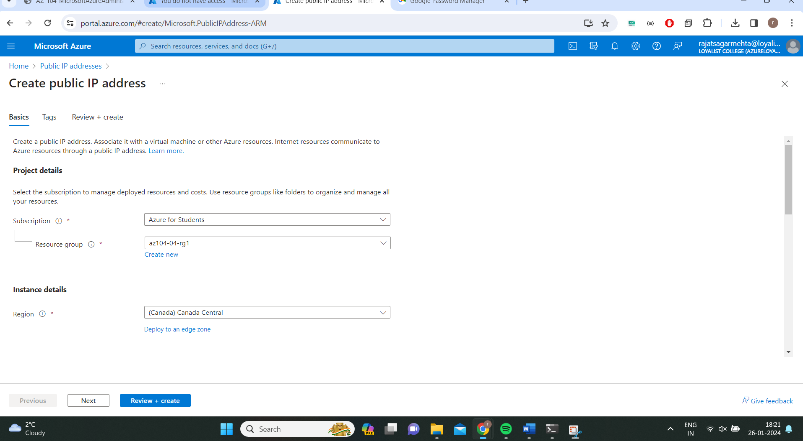

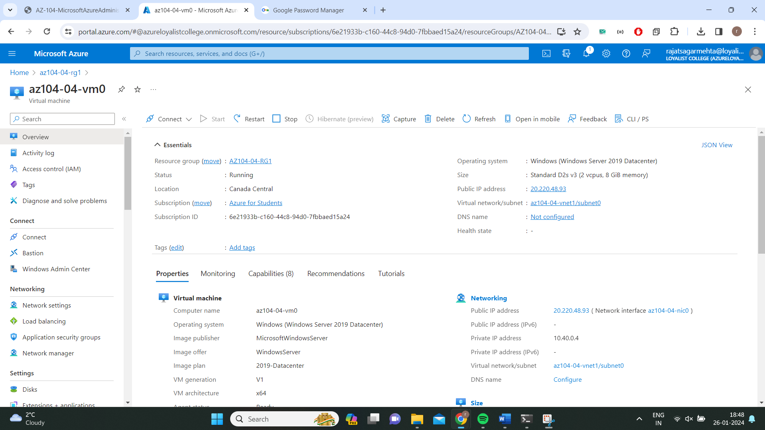

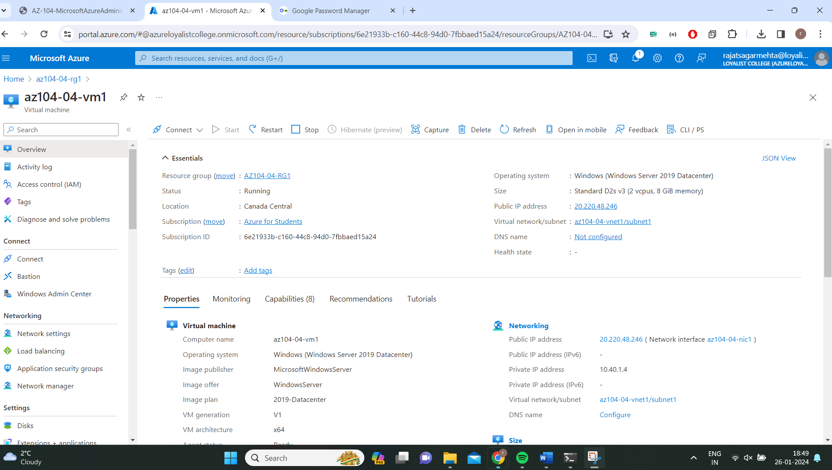

## **Task 4: Configure network security groups**

## **Task 5: Configure Azure DNS for internal name resolution**

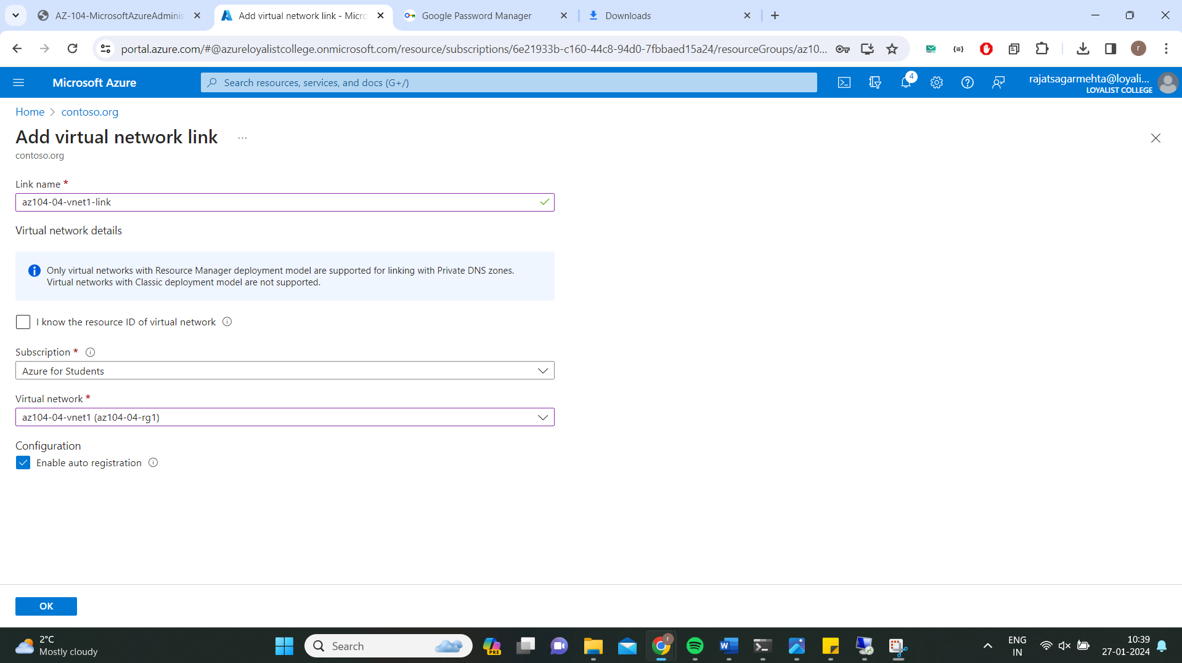

## **Task 6: Configure Azure DNS for external name resolution**

**Task 7.What I learned from this assignment?**

1.This assignment teaches us 2 important aspects of how to host a internal website(contoso.org) and a external website(rajats.ca) on Azure infrastructure.

2.The way we configure the VMs in a resource group and associate the public IPs through a network interfaces .

3.While establishing a remote RDP connection it is important to associate network interface card with a network security group before establishing the remote RDP connection.